An article of cargo, front overhang and rear overhang on a 48’ trailer. The front overhang can be up to 11’. The rear overhang can be much more.

These long lines represent a load. The load is 65’ long. 8-foot front overhang and 9-foot rear overhang.

48’ trailer

Load is 65’, 8-foot front overhang, 9-foot rear overhang.

This represents a 48’ flatbed trailer with no headboard,

Since there is 8 feet of front overhang, would the driver be required to put both securement device within the first two feet of the trailer?

Or would the load be better secured if all of the securement devices were placed equally upon the trailer surface?

393.110(b)(3) is speaking to the length of “an article of cargo” not to the placement of the securement devices. In the prior 2 references of (b)(1) and (b)(2) it is speaking to the length of an “article of cargo”. (b)(1) 5 feet or less and (b)(2) 5 feet but less or equal to 10 feet.

Therefor (b)(3) again is only speaking to the length of an article of cargo that is being secured. Nowhere in 393.110 is it stated “**within**” the first 10 feet of the article of cargo there need to be securement!

As a question how would I carry an article of cargo that extends 11 feet over the front of my trailer? There is no way to secure an article of cargo if it extends over the front of the trailer more than 10 feet. Nowhere in the regulations is there an expectation to secure an article of cargo that is not in contact with the trailer.

The OOS note under 393.110 (b)(3) states:

Tiedowns shall be positioned as follows:

1. Tiedowns spaced 10 feet apart along the length of the vehicle; or,
2. A tiedown every 10-foot segment of the cargo; or,
3. To accommodate anchor points or cargo damage considerations, tiedowns may be spaced or grouped at lengths greater or less than 10 feet.

The title of 393.110 is “What else do I have to do to determine the minimum number of tiedowns?” Not where are tie downs placed. The only part that speaks to the placement of the tiedowns is 393.100 (a) at the end where it refers to 393.106.

In looking at 393.106 it states some of the requirements;

393.106(b) that the cargo must be firmly immobilized or secured on or within a vehicle;

393.106 (c) Items they may roll or shift;

393.106(d) Aggregate working load limit of the securement device

Again, nothing to the requirement of “two straps within the first 10 feet”

393.110(d) “special use trailer”.

I believe that the intent of the law is to secure the article of cargo to where it will not be lost from the trailer during transit. I also believe that the law does not require the actual spacing of securement devices but allows the driver to place them where they will be most effective. The training of the driver is the responsibility of the Carrier. This rule just states that for the length of the article of cargo it requires a certain number of straps. If the cargo is not blocked by the bulkhead, header board, or other cargo then you must add a penalty strap.

I also believe that their needs be guidance in section 393.110, that addresses loads that extend over the front and the rear of the trailer. I believe that it also needs to address that the securement devices and the placement of the securement devices can only be held to the confines of the trailer, this way the rule can require that within the first 10’ of the trailer they have two straps.

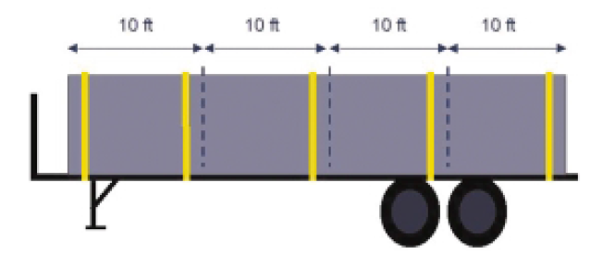



48-foot flatbed trailer with an article of cargo that is 60 feet long. 7 straps cover 393.110(b)(3)

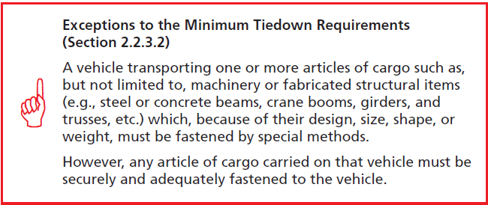

What are all the covered items this exception would cover, and would this exception trump 393.110?

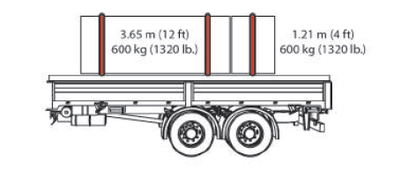

As depicted in the above picture, out of the FMCSA drivers handbook it never shows, or depects an oversize load. I believe this must exist as not every load is held within the confines of a trailers surface area.

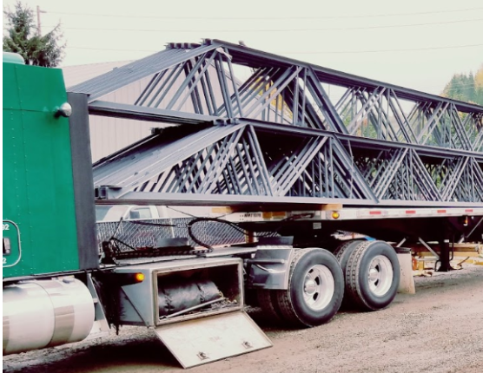

In this example with 10.5 feet front overhang, how would the driver secure this the way you interpreted 393.110(b)(3)? There is no way to secure this within the first 10 feet. Therefore, how would a CMV carry this legally down the road?